16.5(PartⅡ) Carboxylic acid
Name: ____________________ Class: ____________________ Due date: 3.15
1. Which compounds contain the same number of carbon, hydrogen and oxygen atoms? （ ）
W | X | Y | Z
ethyl methanoate | methyl ethanoate | methyl methanoate | ethyl ethanoate
A W and X B W and Y C X and Z D Y and Z

2. An ester is formed when a carboxylic acid reacts with an alcohol.
Which ester is formed when propanoic acid and ethanol react? （ ）
A ${CH}_{3}{CO}_{2}{CH}_{2}{CH}_{3}$ B ${CH}_{3}{CO}_{2}{CH}_{2}{CH}_{2}{CH}_{3}$ C ${CH}_{3}{CH}_{2}{CO}_{2}{CH}_{3}$ D ${CH}_{3}{CH}_{2}{CO}_{2}{CH}_{2}{CH}_{3}$

3. Which structural formula represents methyl propanoate? （ ）
A ${CH}_{3}{CH}_{2}{COOCH}_{3}$
B ${CH}_{3}{COOCH}_{2}{CH}_{2}{CH}_{3}$
C ${CH}_{3}{CH}_{2}{CH}_{2}{COOCH}_{3}$
D ${HCOOCH}_{2}{CH}_{2}{CH}_{3}$

4. The formula of an ester is ${CH}_{3}{CH}_{2}{CH}_{2}{COOCH}_{2}{CH}_{2}{CH}_{3}$
Which acid and alcohol react together to make the ester? （ ）
 | acid | alcohol
A | butanoic acid | butanol
B | butanoic acid | propanol
C | propanoic acid | butanol
D | propanoic acid | propanol

5. Substance Z has the following characteristics.
1 It burns in an excess of oxygen to form carbon dioxide and water.
2 It is oxidised by air to form a liquid smelling of vinegar.
3 It reacts with carboxylic acids to form esters.
What is substance Z? （ ）
A ethane B ethanoic acid C ethanol D ethyl ethanoate

6. The structure of an ester is shown.
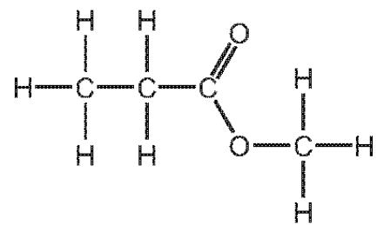
Which row is correct? （ ）
 | name of ester | names of the carboxylic acid and the alcohol used to form the ester
A | methyl propanoate | methanoic acid and propanol
B | methyl propanoate | methanol and propanoic acid
C | propyl methanoate | methanoic acid and propanol
D | propyl methanoate | methanol and propanoic acid
7. The structure of an ester is shown.
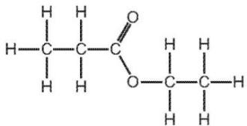
Which alcohol and carboxylic acid produce this ester? （ ）
 | alcohol | carboxylic acid
A | ethanol | ethanoic acid
B | ethanol | propanoic acid
C | propanol | ethanoic acid
D | propanol | propanoic acid
8. The ester linkage showing all the bonds is drawn as or more simply it can be written as - COO- .
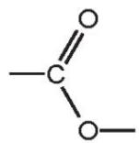
Give the structural formula of the ester ethyl ethanoate.

[1]
ii.Deduce the name of the ester formed from methanoic acid and butanol.
..................................................................................................................................[1]
9. A carboxylic acid and an ester are structural isomers.State the meaning of the term structural isomers.
...........................................................................................................................
...........................................................................................................................
...........................................................................................................................
ii.Draw the structures of the carboxylic acid and the ester which both contain two carbon atoms.
Show all of the atoms and all of the bonds.
Name the carboxylic acid and the ester.
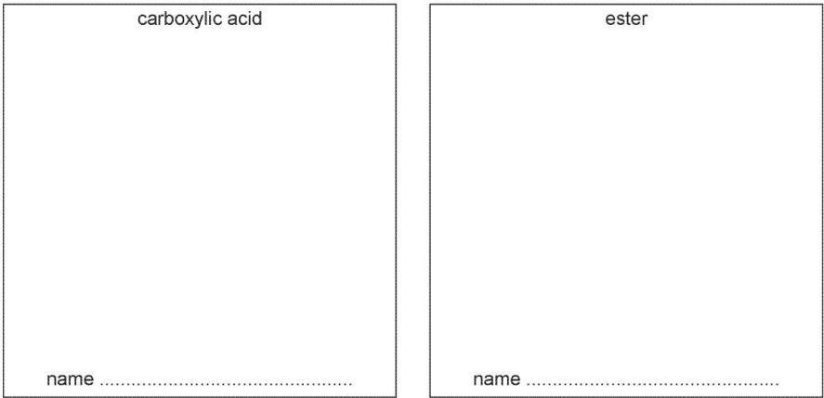[4]

